<https://javatechonline.com/how-to-implement-redis-cache-in-spring-boot-application/>

Openweather API details:

Openweather APi details postman collection(example for Mumbai city): curl --location --request GET 'https://api.openweathermap.org/data/2.5/weather?q=Mumbai &APPID=ba740b7456684cb8d90955612d044920' \

--header 'appid: ba740b7456684cb8d90955612d044920'

YOur API should be:

Input to your API: City

Response of your API:

current Day

Weather description:

Temp

pressure

humidity

wind info:

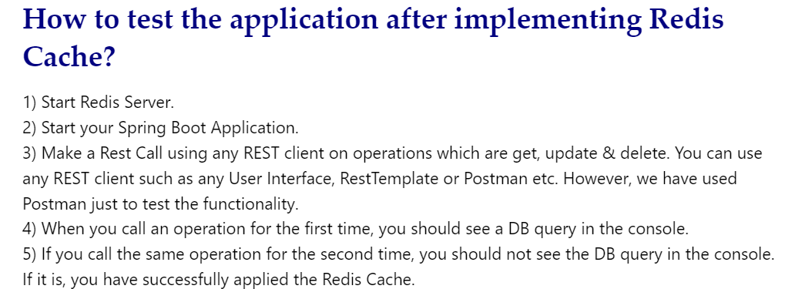

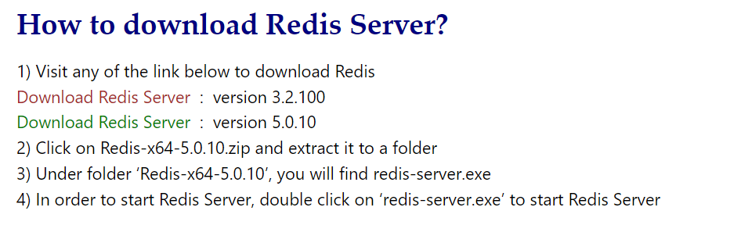

Go to link : <https://github.com/tporadowski/redis/releases>

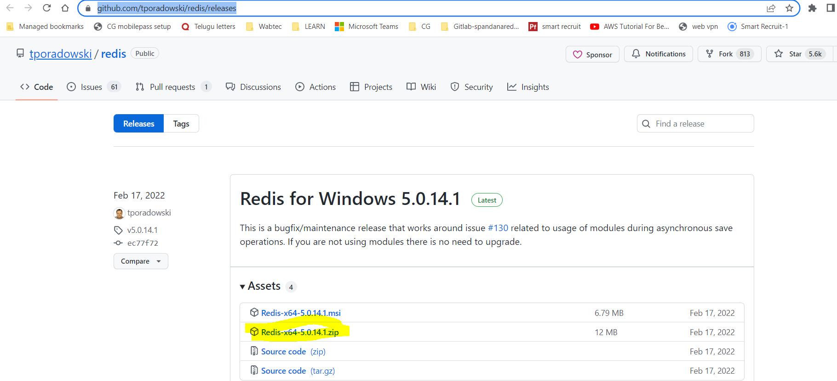

Download and extract the zip file

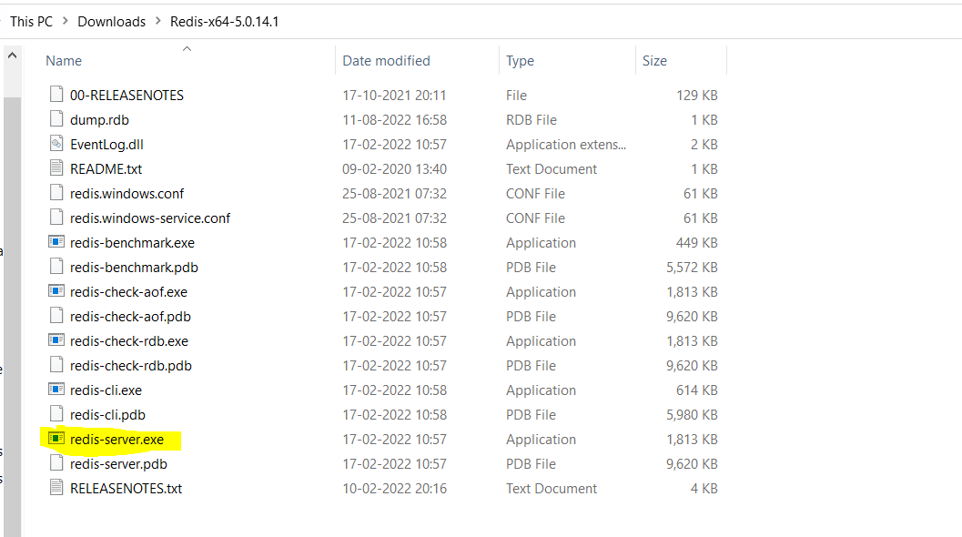

Double clik on the redis-server.exe file which will run the redis server like below.

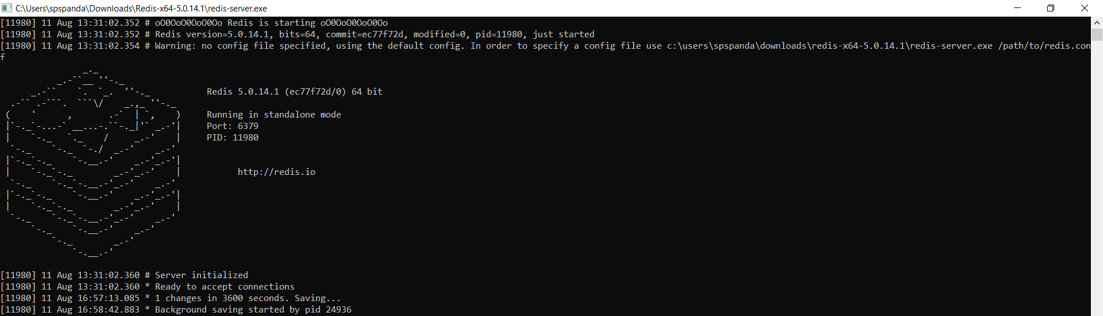

Without cache config hitting the service to get response every time

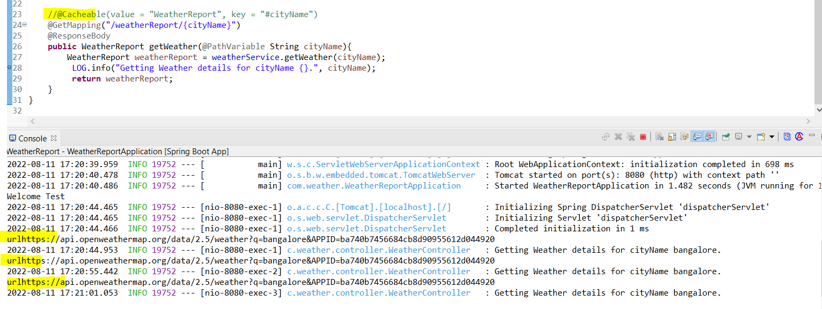

For bangalore city since its already present in cache it did not hit the url

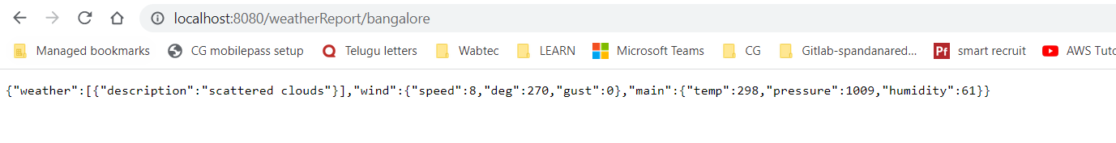

With Redis cache configuration,

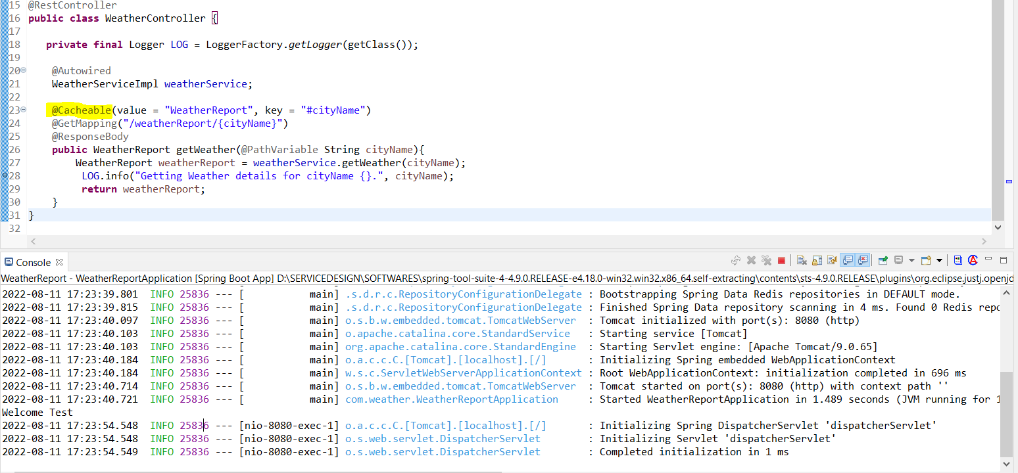

For mumbi first time it hit the url,

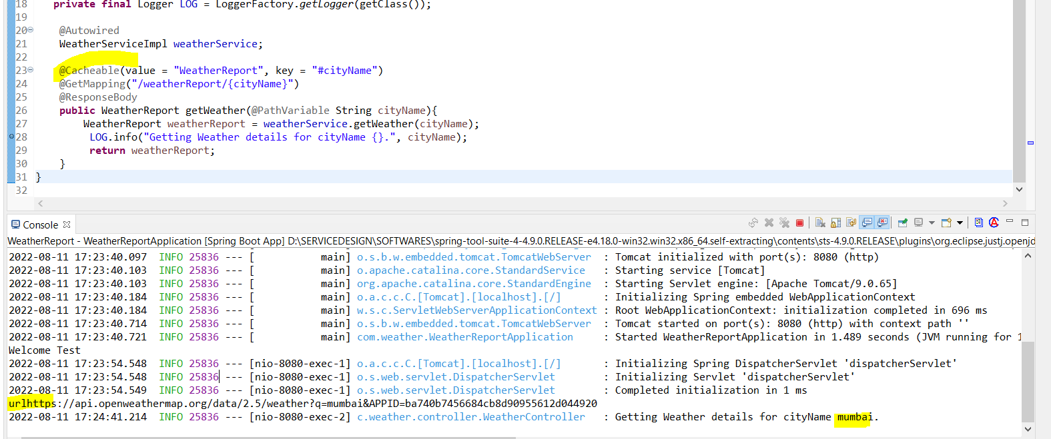

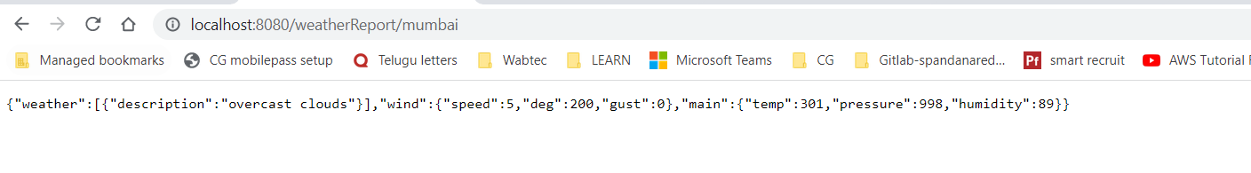

Hit same Mumbai url again,



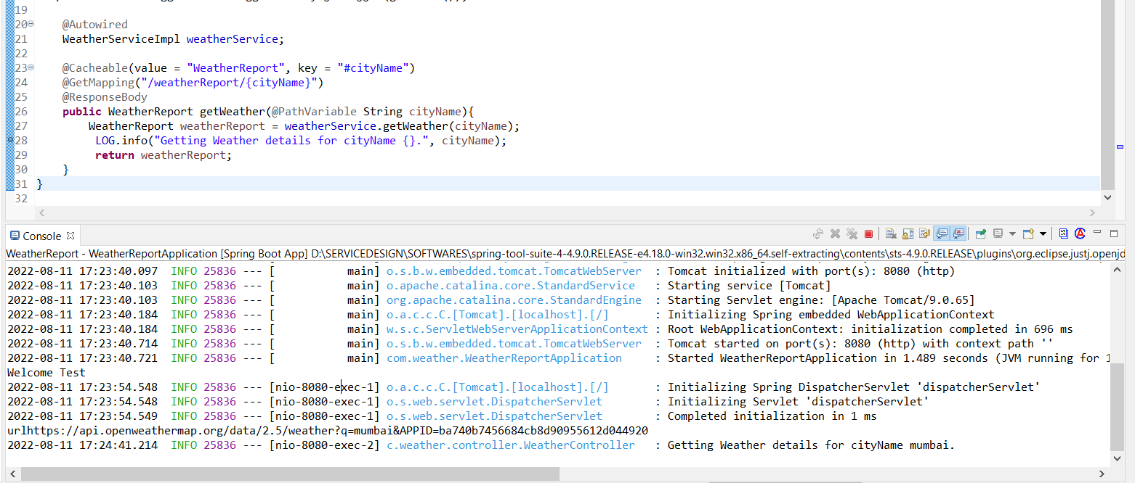

Download the source project .

Import project as maven in sts and run as Springboot application.

Make sure redis server is running.